Unit One: Introduction to Leadership and Management

Topic One: Definitions

Topic Objectives
By end of this topic, you should be able to:-
1. Define management and leadership
2. Explain levels of management
3. Explain neoclassical and classical theories of management
4. Explain functions of management
5. Explain difference between leadership and management
6. Explain qualities of a leader and styles of leadership

Topic 1: What is management?
Management is the art of getting things done through people in order to achieve stated organizational objectives using available resources efficiently and effectively.
Management is also the systematic process involving planning, organizing, staffing, leading and controlling the efforts of organizational members and using all other resources to achieve stated organizational objectives.
Staffing= Staffing refers to the process of finding the right employee with appropriate qualifications or experience and recruiting them to fill a position, role, or job.
• There are six main resources in an organization (6M)
- 1. Money
- 2. Manpower
- 3. Machines
- 4. Materials
- 5. Management (methods)
- 6. Minutes (time)
- Management is also defined as the process by which resources are mobilized, combined and coordinated to effectively to achieve organizational objectives.
- It is a process that utilizes organizational resources in the most effective and efficient manner, in order to attain stated organizational objectives.
Efficiency and Effectiveness
- Efficiency in management refers to optimal (most favorable or desirable ; best) utilization of organization resources with minimal wastage. It is also the relationship between achieving objectives and consumption of resources.
• Effectiveness refers to attaining specific organizational goals that are timely and challenging. It is also an outcome measure of the interventions that improve peoples health under ordinary circumstances and in ordinary settings.

Efficiency =the state or quality of being able to accomplish something with the least waste of time and effort.
Effectiveness = the capability of producing a desired result or the ability to produce desired output.
Management versus Administration
• Administration is part of management work but more concerned with execution.
Administration may refer to: Management of organizations. Management, the act of directing people towards accomplishing a goal.
• A manager is said to be performing administrative work when he/she is involved in interpreting policies of the organization and putting into plans and having those plans implemented. policies are principles, rules, and guidelines formulated or adopted by an organization to reach its long-term goals. It is a predetermined course of action.
• At every level of management, managers perform some work which involves execution or “doing” which is one that completes the administrative process.
• Therefore administration is the total of planning, organizing, controlling, coordinating and also operating work.

Who is a manager?
- This is an individual employed by an organization who is responsible and accountable for efficiently accomplishing the goals of the organization.
- Managers focus on coordinating and integrating resources using the functions of planning, organizing, supervising, staffing, evaluating, negotiating and representing
Characteristics of a manager
- Managers have assigned positions within a formal organization.
- They have legitimate source of power due to delegated authority that accompanies their position.
- They direct willing and unwilling subordinates.
- Since managers work in a formal organization, they have a greater formal responsibility and accountability for rationality and control than leaders.
- They are also expected to carry out specific functions, and responsibilities.
- Managers also manipulate people, the environment, money, time, and other resources to achieve organizational goals
- Managers work at various levels in an organization. The number of levels will depend on the size of the organization. Generally three levels of management are used.
Importance of management
- To meet the challenge of change
- Accomplishment of group goals
- Effective utilisation of business
- Resource development
- Sound organizational structure
- Directing of the organization
- Integration of various interest
- Stability innovation
- Coordination and team spirit
- Tackling problems
- A tool for personality development
- It helps in Achieving Group Goals - It arranges the factors of production, assembles and organizes the resources, integrates the resources in effective manner to achieve goals. It directs group efforts towards achievement of pre-determined goals. By defining objective of organization clearly there would be no wastage of time, money and effort. Management converts disorganized resources of men, machines, money etc. into useful enterprise. These resources are coordinated, directed and controlled in such a manner that enterprise work towards attainment of goals.
- Optimum Utilization of Resources - Management utilizes all the physical & human resources productively. This leads to efficacy in management. Management provides maximum utilization of scarce resources by selecting its best possible alternate use in industry from out of various uses. It makes use of experts, professional and these services leads to use of their skills, knowledge, and proper utilization and avoids wastage. If employees and machines are producing its maximum there is no under employment of any resources.
Reduces Costs - It gets maximum results through minimum input by proper planning and by using minimum input & getting maximum output. Management uses physical, human and financial resources in such a manner which results in best combination. This helps in cost reduction.

• Levels of management
- 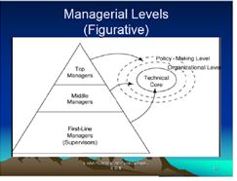

1. First level management:
- The first level managers are also referred as first line managers. they are responsible for supervising the work of non-managerial personnel and the day to day activities of a specific work units or ward. Non-managerial employees are employees who do not have any management role but are responsible for executing or carrying out individual jobs or functions for the organization. They are in-charge of executionary functions of an organization. They are expected to perform the functions as per their job description. They are entrusted with specific functions depending on the department within which they are employed.
- They are the lowest level. In a hospital setting these would include, ward In-charge. They are responsible for clinical practice, assigning staff to patients, interfacing with the public, patient care delivery
- Personnel development, ensuring compliance with regulatory and professional standards, maintaining discipline and motivating staff to achieve the organizational goals.
- First level managers are also responsible for fostering inter-disciplinary, collaborative and strategic planning
2. Middle level Management:
- The middle level managers supervise a number of first level managers usually with related specialties (a branch of medicine or surgery. an area of specialization) or in a given geographical area.
- They have a 24hr responsibility for their defined area.
- Typically middle level managers act as liaison (communication or cooperation which facilitates a close working relationship between people or organizations) between upper management and first level managers.
- They are responsible for implementing the policies and plans developed by top managers. They also supervise and coordinate the activities of first line managers
- A middle level manager maybe referred as a supervisor, director or assistant director. This group constitutes the largest group of managers
3. Upper level management (top managers):
- This refers to top executives (such as Chief Nurse,rco) to whom the middle managers report.
- They are responsible for establishing organizational goals and strategic plans for the entire organization and operating policies for the entire division
- They also ensure integration of work units to achieve the organization mission and buffering (lessen or moderate the impact of (something) the effects of the external environment on workers within the organization.
- Top managers are relatively a small group.
The ten roles are: 1 .Figurehead. 2. Leader. 3. Liaison. 4. Monitor. 5. Disseminator. 6. Spokesperson 7. Entrepreneur 8. Disturbance Handler. 9. Resource Allocator. 10. Negotiator.

Topic 1: Management Roles
Henry Mintzberg (1973) identified ten management roles which he placed in three categories: Interpersonal role, informational roles and decisional roles.
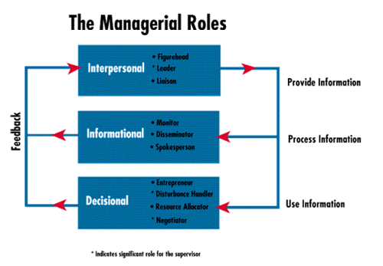
Figurehead=a nominal leader or head without real power. Titular head.
- Informational management roles: communication-based
- Decisional management roles: action-based roles for making and implementing decisions
- Interpersonal management roles: relationship-based.

Interpersonal roles:
1. Figure head role: symbolizes the organization or department and performs ceremonial duties. As a manager, you have social, ceremonial and legal responsibilities. You're expected to be a source of inspiration. People look up to you as a person with authority, and as a figurehead.
2. Leader: determines the Mission and Objectives of the organization and sees that they are accomplished effectively. He hires, trains and motivates employees and encourages them to do better
3. Liaison role: Involves networking with outside organizations, expanding information sources, like conferences, professional meetings etc. Acts as a link between people, groups or organizations within and without the organization. Liaison (communication or cooperation which facilitates a close working relationship between people or organizations)
Informational role:
4. Monitor: As a monitor, the manager informally seeks information about the organization through internal networks, gossips, and observations. (Get information useful to organization). He/she tours of the organization and holds formal and informal meetings to provide information about the needs of the organization. Monitor=Observe and check the progress or quality of (something) over a period of time; keep under systematic review. Watch, keep track of.
5. Disseminator: A manager is a link in the organization chain of command. He shares information from outside the organization and between work units (sharing information improves job satisfaction). This is where you communicate potentially useful information to your colleagues and your team.
6. Spokesperson: The manager shares information with individuals outside the organization, attends meetings, offering continuing education and participates in professional organizations. In this role, you're responsible for transmitting information about your organization and its goals to the people outside it.
Decisional Roles:
7. The entrepreneur: The manager looks for profitable investments for the organization to improve its performance (start a school of nursing). Entrepreneur= a person who sets up a business or businesses, taking on financial risks in the hope of profit.
8. Resource allocator; Managers schedule their own time (work plan). They decide how resources are distributed and with whom he will work most closely with. You'll also need to determine where organizational resources are best applied. This involves allocating funding, as well as assigning staff and other organizational resources.
9. Negotiator; Enters into negotiation with other parties e.g. to enter into a long term relationship with a supplier
10. Disturbance handler: Responds to unforeseen circumstances eg. Replacement of a sick staff, missing equipment, disease outbreaks (shift staffs).When an organization or team hits an unexpected roadblock; it's the manager who must take charge.

ATTRIBUTES AND QUALITIES OF A MANAGER
• Technical competence
Technical=relating to a particular subject, art, or craft, or its techniques.
(Especially of a book or article) requiring special knowledge to be understood.
Technical skills are the abilities and knowledge needed to perform specific tasks. They are practical, and often relate to mechanical, information technology, mathematical, or scientific tasks. Some examples include knowledge of programming languages, design programs, mechanical equipment, or tools. They are also typically a type of hard skill. Hard skills are those that can be taught in a classroom, and can be defined, evaluated, and measured (as opposed to soft skills, which are personal attributes that help you succeed at work).
• Social & human skills=
The human or the interpersonal skills are the skills that presen the managers' ability to interact, work or relate effectively with people. These skills enable the managers to make use of human potential in the company and motivate the employees for better results.
• Conceptual ability = Conceptual means related to ideas and concepts formed in the mind. Pertaining to concepts or to the forming of concepts. Conceptual skills are the abilities that allow an individual to better understand complex scenarios and develop creative solutions. From a management perspective, these skills are valuable because those who have them can approach complicated workplace situations in a variety of different ways. No matter what industry your compan operates in, it will face challenges that require innovative and creative ways of thinking. In these situations, conceptual skills are the most beneficial to the organization. A conceptual leader can think through their ideas, transforming thoughts into action-driven solutions.
.

Topic Two: Historical Development of Management

Management has been developed through the following periods:

i) The classical theories

ii) Neo classical theories
SCIENTIFIC / CLASSICAL APPROACH
1910’s
Described management as a science
– focused on formal structure, technical requirements of the organisation and general sets of principles
-Listed duties of a manager
HUMAN RELATIONS APPROACH
– focused on the informal organisation and the psychological & social needs of people at work
Classical theories:
- The exponents of classical theories were principally concerned with the structure and mechanics of organizations. They included the following
1. Henri Fayol (French Industrialist 1841-1925) –Administrative theory (search for principles of Management
2. Fredrick W. Taylor (1856-1915) – A Mechanical Engineer in the USA (The Scientific Management Theory)
3. Max Weber (1864-1920) – A German Sociologist. The Theory of Bureaucracy
NB. Classical/scientific managers relied on their experience. They advocated for what worked.

Scientific Management Theory
was developed by Fredrick Taylor (1900-1930) (A mechanical Engineer) in 1911
- Taylor conducted research on methods of training workers for increased productivity. He advocated that work be studied scientifically to determine the one best way to perform each task.
- Taylor postulated that if workers could be taught the “one best way to accomplish a task,” productivity would increase.
- He came up with the basic principles of scientific management:
• Systematically analyzed human behavior at work
• His model was machine with cheap , interchangeable parts that was doing a specific function
• Reduce complex organizations into machine like
• Make individuals into equivalent machine parts
He studied;
- Interaction of human characteristics
- Social environment
- Tasks
- Physical environment
- Capacity
- Speed
- Durability cost
FAYOL’S 6 ACTIVITIES OF INDUSTRIAL UNDERTAKING
1. Technical e.g. production
2. Commercial e.g. buying and selling commercial=related to the activity of buying and selling.
3. Financial activities e.g. securing capital
4. Security e.g. safeguarding property
5. Accounting e.g. providing financial information

Principles of scientific management (Fredrick Winslow Taylor)
1. Observing the workers’ performance through time and motion study to determine the one best way to carry out each task (develop a science for each element of man’s work to maximize organization output)
2. Scientifically selecting the best worker to perform each job, that is the person with characters and abilities needed to carry out job tasks in the most efficient manner.
3. Training the selected worker to perform tasks in the most efficient manner
4.Paying the worker a differential piece rate to motivate them to perform the tasks in prescribed, efficient fashion
A differential piece-rate system is a method of wage payment in which after tests have set a standard time for any task assigned the worker gets a high piece rate for completing the job within the allotted time and lower piece rate for completing the job beyond the allotted time.
5. Appointing a few highly skilled workers to managerial positions and giving each manager responsibility for planning tasks for subordinate workers
6. Appointing a foreman(a male worker who supervises and directs other workers) for each aspect of the work and instructing the production worker to report to a different functional foreman for each aspect of the job
F. W TAYLOR’S ACHIEVEMENTS
1. Raised productivity of shovellers from 16 to 59 tons/day i.e. 4 fold
2. Reduced no. of yard laborers from 500- 140
3. Revolutionarised the art of cutting metals
4. Doubled speed at which fine steelwork was done
5. Increased production in one instance by 369% and increased the wages by 60%%= extra profit!!!
was nicknamed "Speedy" Taylor for his reputation as an efficiency expert.

FAILURES OF F. W TAYLOR’S
1. He dehumanized management theory
2. The aspect of management which the laws of science did not as yet apply were to be subject to collective bargaining e.g. class interests
3. Taylor was hated by unions
4. Laws were passed to keep his methods out of military arsenal . The federal government (the military, actually) thought his ideas were dangerous, and scientific management was banned by federal law from ever being implemented in that sector
Key Differences between Fayol and Taylor’s Theory of Management
The difference between Fayol and Taylor’s Theory of Management, are explained in the points presented below:
- Henry Fayol is a father of modern management who enunciated fourteen principles of management, for improving overall administration. As against, F.W. Taylor is a father of scientific management who developed four principles of management, for increasing overall productivity.
- Henry Fayol introduced the concept of General theory of administration. F.W. Taylor laid down the concept of Scientific Management.
- Henry Fayol emphasized the working of top level management, whereas F.W. Taylor stressed on the working of production level management.
- Fayol’s management theory has universal applicability. Unlike Taylor, whose management theory applies to a number of organizations only.
- The basis of formation of Fayol’s theory is the personal experience. Conversely, Taylor’s principles rely on observation and experimentation.
- Fayol is oriented towards managerial function. On the contrary, Taylor focussed on production and engineering.
- The system of wage payment determined by Taylor is differential piece rate system, while Fayol stressed on sharing of profits with managers.
- The approach of Taylor is termed as Engineer’s approach. In contrast, Fayol’s approach is accepted as manager’s approach.

Administrative theory
Administrative theory of management was developed by (Henri Fayol 1841-1925)
- While the scientific management focused on the tasks to be performed by the worker, administrative management focused on the development of broad administrative principles applicable to general and higher managerial level.
- Henri Fayol (1925) also was the first person to identify the management functions of planning, organization, command, coordination, and control. Fayol also described fourteen management principles as follows.

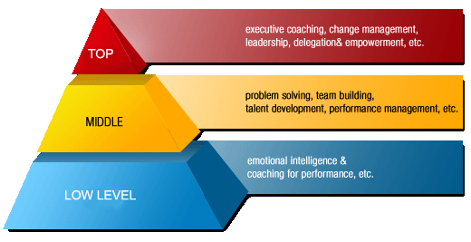
Division of labor= the assignment of different parts of a task to different people in order to improve efficiency & so that participants may specialize.

FAYOL’S 14 PRINCIPLES OF MANAGEMENT
1. Specialization or division of labor
- Reduces span of attention or effort for any one person or group.
- Develops practice and familiarity
- Specializing encourages continuous improvement in skills and the development of improvements in methods.
2. Authority
- Rights to give order
- Should be accompanied by responsibility
- The right to give orders and the power to exact obedience.
3. Discipline.
- This is defined as respect for agreements which are directed at achieving obedience. Obedience must prevail throughout the organization as it’s essential for smooth running of an enterprise.
- outward mark of respect accordance with formal or informal agreement between firm and employees
- No slacking, bending of rules.
4. Unity of command.
- Every subordinate should receive orders and be accountable to only one supervisor. Dual or multiple commands is a perpetual source of conflict. Unity of command avoids conflicting orders and ensures order stability in the organization
- One man, one superior -Each employee has one and only one boss.
5. Unity of direction.
According to this principle, each group of activities having the same objective must have one head and one plan.
- One head, one person (director) and one plan for a group of activities with one objective. A single mind generates a single plan and all play their part in that plan.
6. Subordination of Individual Interests to general interests.
- Efforts should be made to reconcile individual interests with common interests. When there is conflict between the two, the interests of organization should prevail over individual interests.
- Interest of one individual or one group should be subordinate( not prevail over the general good (total workgroup)
- When at work, only work things should be pursued or thought about.
7. Remuneration of personnel.
- The amount of remuneration and the methods of payment should be just and fair and should provide maximum possible satisfaction to both employees and employers pay should be fair to both employee and the firm.
- Employees receive fair payment for services, not what the company can get away with.
Centralization refers to a setup in which the decision-making powers are concentrated in a few leaders at the top of the organizational structure. Decisions are made at the top and communicated to lower-level managers for implementation.
8. Centralization;
- The degree of concentration of authority should be based upon optimum utilization of all faculties of the personnel.
- Depending on size of company and quality of managers.
- Consolidation of management functions.
- Decisions are made from the top.
9. Scalar Chain (line of authority).
- There should be a clear line of authority ranging from top to down of the organization. All upward and down ward communication should flow through each position of authority along the scalar chain. There should be an unbroken chain of authority extending from top executive to lowest level worker.
- Formal chain of command running from top to bottom of the organization, like military
10. Order.
- All materials and personnel have a prescribed place, and they must remain there. The right man should be in the right place. A place for everything &everything in its own place, the right man in the right place.
- All materials and personnel have a prescribed place, and they must remain there.
11. Equity.
- This means that employees should be treated with justice and kindness. Managers should be fair and impartial in their dealings with subordinates Treat every employee with equity &justice.
- A combination of justice and kindliness towards employees.
- Equality of treatment (but not necessarily identical treatment)

12. Stability of tenure of personnel. Tenure= a period for which an office is held.
- Employees cannot work efficiently unless job security is assured of them.
- Employees need time to settle into their jobs,
- This may be lengthy times.
- Limited turnover of personnel.
- Lifetime employment for good workers.
13. Initiative.
Employees at all levels should be given the opportunity to take initiative and exercise judgment in the formulation and execution of plans. Initiative refers to the freedom to think for oneself and use discretion in doing work. It develops the interest of employees in their jobs and provides job satisfaction to them.
Thinking out a plan and do what it takes to make it happen within levels of authority and responsibility all staff should be encouraged to show initiative i.e. new ways of doing things.
14. Esprit de corps.
This refers to harmony and mutual understanding among members of the organization. Unity among the staff is the foundation of success in any organization
- Harmony is a great strength to organizations
- Team work should be encouraged.

MAX WEBER
- ''Bureau' (French, borrowed into German) is a desk, or by extension an office (as in 'I will be at the office tomorrow'; 'I work at the Bureau of Statistics').
- 'Bureaucracy' is rule conducted from a desk or office, i.e. by the preparation and dispatch of written documents - or, these days, their electronic equivalent.
- Max Weber, a sociologist who began to study the new forms of organization being developed for managing large numbers of people in far-flung and complex activities.
- Germany had been an early leader in developing a civil service. At the same time, German industry was beginning to adopt the organizational methods developed in the United States.
- Surveying this scene, Weber attempted to isolate the elements common to all of these new organizations
- Weber concluded that all these new large-scale organizations were similar.
- Each was a bureaucracy.
- Today many of us regard bureaucracy as a dirty word, suggesting red tape, inefficiency, and officiousness
-cracy= denoting a particular form of government, rule, or influence. Bureaucracy is an organization or government by many bureaus, administrators, and petty officials.

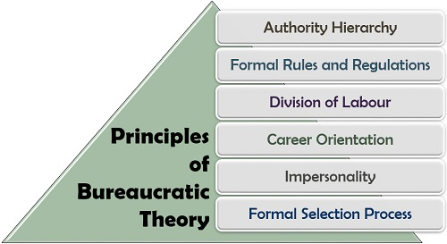
According to the bureaucratic theory of Max Weber, such a structure was indispensable in large organizations in structurally performing all tasks by a great number of employees. In addition, in a bureaucratic organization, selection and promotion only occur on the basis of technical qualifications.
A characteristic is a distinguishing trait or quality, i.e. blue eyes are a characteristic of a person, a sense of humor is a characteristic of a person.
A principle is something in which you believe strongly, i.e. honesty in the workplace is a principle, and commitment is a principle. It is a value that is a guide for behavior or evaluation.
Impersonality=a lack of friendly human feelings or atmosphere that may have the effect of making you feel unimportant; absence of human character or of the traits associated with the human character
Bureaucracy in business is a hierarchical organization or a company that operates by a set of pre-determined rules. In a large business, there are typically several diverse functions that need to be performed by specialized sub-institutions that report up the management chain. Bureaucracy is an organizational structure that is characterized by many rules, standardized processes, procedures and requirements, number of desks, meticulous division of labor and responsibility, clear hierarchies and professional, almost impersonal interactions between employees”.
Bureau =an office or department for transacting particular business.
"a news bureau"
Similar: agency, service, office, business, company, firm, organization, operation

The theory was developed by Max Weber (1864-1920).
Webber’s rational bureaucracy states that employees performing a large variety of tasks in an organization must follow established rules and regulations in order to ensure uniformity and rationality of output. The following are the characteristics of an ideal organization as described by Weber
Characteristics of an ideal organization by Weber
I. Division of labor: there should be clearly defined authority and responsibility given as official duties
II. Hierarchy of authority: Positions should be organized in a hierarchical manner resulting in scalar chain
III. Formal selection: Employees should be selected on the basis of technical skill, formal examinations or by education or training
IV. Formal rules: There must be formal rules and controls regarding the conduct of official duties and administrations
FEATURES DEVELOPED TO MAKE BUREAUCRACIES RATIONAL (based on reason/logic rather than on emotion/impulse)
(1) Functional specialization
(2) Clear lines of hierarchical authority,
(3) Expert training of managers,
(4) Decision making based on rules and tactics developed to guarantee consistent and effective pursuit of organizational goals.
RATIONAL BUREAUCRACY
Weber noted additional features of rational bureaucracies that are simple extensions of the four just outlined,
1. To ensure expert management, appointment and promotion are based on merit rather than favoritism, and those appointed treat their positions as full-time, primary careers.
2. To ensure order in decision making, business is conducted primarily through written rules records, and communications
What is a bureaucratic organization?-google
According to the bureaucratic theory of Max Weber, bureaucracy is the basis for the systematic formation of any organisation and is designed to ensure efficiency and economic effectiveness. It is an ideal model for management and its administration to bring an organization’s power structure into focus. With these observations, he lays down the basic principles of bureaucracy and emphasizes the division of labor, hierarchy, rules and impersonal relationship.
Max Weber’s six characteristics of the bureaucratic theory
Below is a more detailed explanation of the bureaucratic management principles.
The 6 bureaucracy characteristics are:
- Task specialization (Specialization and Division of Labor)
- Hierarchical layers of authority
- Formal selection
- Rules and requirements
- Impersonal (Impersonality and Personal Indifference)
- Career orientation
1. Task specialization Tasks are divided into simple, routine categories on the basis of competencies and functional specializations. Every employee is responsible for what he/she does best and knows exactly what is expected of him/her. By dividing work on the basis of specialisation, the organisation directly benefits. Each department has specific powers. As a result, there is a delineation of tasks and managers can approach their employees more easily when they do not stick to their tasks. Every employee knows exactly what is expected of him/ her and what his/ her powers are within the organisation. Every employee has a specific place within the organisation and is expected to solely focus on his/ her area of expertise. Going beyond your responsibilities and taking on tasks of colleagues is not permitted within a bureaucracy.
2. Hierarchical layers of authority Managers are organised into hierarchical layers, where each layer of management is responsible for its staff and overall performance. In bureaucratic organizational structures, there are many hierarchical positions. This is essentially the trademark and foundation of a bureaucracy. The hierarchy of authority is a system in which different positions are related in order of precedence and in which the highest rank on the ladder has the greatest power. The bottom layers of bureaucratic organizational structures are always subject to supervision and control of higher layers. This hierarchy reflects lines of bureaucratic communication and the degree of delegation and clearly lays out how powers and responsibilities are divided.
3. Formal selection All employees are selected on the basis of technical skills and competences, which have been acquired through training, education and experience. One of the basic principles is that employees are paid for their services and that level of their salary is dependent on their position. Their contract terms are determined by organisational rules and requirements and the employee has no ownership interest in the company.
4. Rules and requirements Formal rules and requirements are required to ensure uniformity, so that employees know exactly what is expected of them. In this sense, the rules and requirements can be considered predictable. All administrative processes are defined in the official rules. By enforcing strict rules, the organisation can more easily achieve uniformity and all employee efforts can be better coordinated. The rules and requirements are more or less stable and always formalised in so-called official reports. Should new rules and requirements be introduced, then senior management or directors are responsible for this.
5. Impersonal Regulations and clear requirements create distant and impersonal relationships between employees, with the additional advantage of preventing nepotism or involvement from outsiders or politics. These impersonal relationship are a prominent feature of bureaucracies. Interpersonal relationships are solely characterised by a system of public law and rules and requirements. Official views are free from any personal involvement, emotions and feelings. Decisions are solely made on the basis of rational factors, rather than personal factors.
6. Career orientation (the direction that an individual takes, career-wise, throughout his or her life). Employees of a bureaucratic organisation are selected on the basis of their expertise. This helps in the deployment of the right people in the right positions and thereby optimally utilising human capital. In a bureaucracy, it is possible to build a career on the basis of experience and expertise. As a result, it offers lifetime employment. The right division of labour within a bureaucratic organisation also allows employees to specialise themselves further, so that they may become experts in their own field and significantly improve their performance. Deployment= the action of bringing resources into effective action. Human capital =the skills, knowledge, and experience possessed by an individual or population, viewed in terms of their value or cost to an organization or country.
Topic Two: Summary
CONCLUSION & NOTE ON SCIENTIFIC MANAGEMENT
There is a best machine for each job, so there is a best working method by which people should undertake their jobs. All job processes should be analyzed into discrete tasks & via this management find the ‘one best’ way to perform each task.

Topic 3: Neoclassical theorist/ motivational theories
In the early 1920s, a shift away from classical management theory took place as theorists began to consider the human side of an organization and the social needs of employees. In this lesson, you will learn about the evolution of the neoclassical theory of management and its two sources: the human relations movement and the behavioral management movement.
A Shift Away from Classical Management Theory
In the early 1920s, classical management theorists, such as Frederick Taylor, Henry Gantt, and Frank and Lillian Gilbreth, spent their time researching how a specific job was done, what steps were taken by an employee to complete the work, and the amount of time it took a worker to complete a task using different methods. They then used this information to determine the most effective way of completing a task. While these individuals focused on the science of creating specialized work processes and workforce skills to complete production tasks efficiently, critics began to scrutinize classical management theory for its potentially harmful effects on workers.
It was not so much the methodology of finding the most efficient way to complete a task that concerned critics, but the underlying assumption of classical management theorists that managers and workers would meet halfway on their attitudes towards standardization. However, many believed that placing too much emphasis on standardization of jobs and workers had not created this 'mental revolution' that Taylor and his associates had hoped for, but rather had inadvertently created an attitude among managers at the time that employees were nothing more than an appendage to a machine. While machines and processes could be standardized, critics argued that it was unrealistic to expect that standardization among emotional beings; the two needed to be looked at individually. So, as Taylor and other classical management theorists continued their work on standardization, others started to conduct research on the worker, and thus, the neoclassical theory of management was born.
The Emergence of the Neoclassical Theory of Management
The neoclassical theory was an attempt at incorporating the behavioral sciences into management thought in order to solve the problems caused by classical theory practices. The premise of this inclusion was based on the idea that the role of management is to use employees to get things done in organizations. Rather than focus on production, structures, or technology, the neoclassical theory was concerned with the employee. Neoclassical theorists concentrated on answering questions related to the best way to motivate, structure, and support employees within the organization.
Studies during this time, including the popular Hawthorne studies, revealed that social factors, such as employee relationships, were an important factor for managers to consider. It was believed that any manager who failed to account for the social needs of his or her employees could expect to deal with resistance and lower performance. Employees needed to find some intrinsic value in their jobs, which they certainly were not getting from the job that was highly standardized. Rather than placing employees into job roles, where they completed one specific task all day with little to no interaction with coworkers, employees could be structured in such a way that they would frequently share tasks, information, and knowledge with one another. The belief was that once employees were placed into this alternate structure, their needs for socialization would be fulfilled, and thus they would be more productive.
Two Movements in the Neoclassical Theory
The neoclassical theory encompasses approaches and theories that focus on the human side of an organization. There are two main sources of neoclassical theory: the human relations movement and the behavioral movement. The human relations movement arose from the work of several sociologists and social physiologists who concerned themselves with how people relate and interact within a group. The behavioral movement came from various psychologists who focused on the individual behavior of employees. To better understand these movements, let's take a look at how the work of these various sociologists and psychologists influenced management thought.
Human Relations Movement
The human relations movement was a direct result of Elton Mayo and Fritz J. Roethlisberger's Hawthorne studies, which were designed to find ways to increase worker productivity at Western Electric's Hawthorne Works factory by assessing working conditions related to things such as lighting levels, rest periods, and the length of a work day

Neoclassical theorists also referred as human relation or motivational theorists were concerned with the human factor at work place. They were concerned with motivation, group relationships and leadership. They wanted to discover what it is that triggers and sustains human behavior. The major assumption of this theory is that people desire social relationships, respond to group pressures, and search for personal fulfillment.

Definitions of Motivation
- “Motivation takes place when people expect that a course of action is likely to lead to the attainment of a goal - a valued reward that satisfies their particular needs”. (Armstrong:1997).
- “The willingness to exert high levels of effort toward organisational goals, conditioned by the effort’s ability to satisfy some individual needs”. (Robbins:1998).
Concept of Motivation
- The underlying concept of motivation is some driving force within individuals by which they attempt to achieve some goal in order to fulfil some need or expectation.
- Peoples behaviour is determined by what motivates them. Their performance is a product of both ability level and motivation.
- Performance = function (ability X motivation)
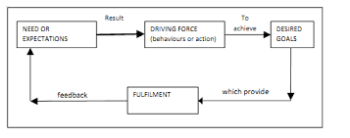
Types of Motivation Theories
- Content Theories
- Process Theories
CONTENT THEORIES
- These theories attempt to explain those specific things which actually motivate the individual at work.
- These theories are concerned with identifying peoples needs and their relative strengths, and the goals they pursue in order to satisfy these needs.
- Content theories place emphasis on what motivates human behavior i.e. the wants and needs that people are trying to satisfy
Content Models
- The Hierarchy of Needs Theory (Maslow:1943).
- The ERG Theory (Alderfer:1972).
- The Acquired Needs Theory/Achievement Motivation Theory(McClelland:1961).
- The Dual-Factor Theory (Herzberg:1968

PROCESS THEORIES
- Process theories- These seek to explain specific actions focusing on the thought process that people experience prior to behaving in a particular manner e.g H. Vroom

Process Models
- Theory X, Theory Y (McGregor:1960)
- Expectancy Theory (Vroom:1964 and Porter & Lawler:1968)
- Equity Theory (Adams:1965)
Hawthorne Studies
Prof. Elton Mayo (Australian) (1880-1949) Psychologist, carried research at the Western Electric Company in the USA(1.1 1927-1932). He was concerned about studying people, in terms of their social relationships at work. He carried out a study at the Hawthorne plant of the Western Electric Company with emphasis on the worker rather than the work
Conclusions from Hawthorne Theory (Elton Mayo)
- Individuals cannot be treated in isolation, but must be members of a group
- The need to belong to a group and have status within it is more important than monetary incentives or good physical working conditions
- Informal (or unofficial) groups at work exercise strong influence over the behavior of workers
- Supervisors and managers need to be aware of these social needs and cater for them if workers are to collaborate with the official organization rather than work against it.
MASLOW HIERARCHY OF NEEDS (Theory of Motivation)
- Maslow’s studies into human behavior led him to propose a theory of needs based on hierarchical model with the basic needs at the bottom and higher needs at the top as shown in the adjacent diagram
- Basic proposition is that people are wanting beings, they always want more, and what they want depends on what they already have.
- Hierarchy ranges through 5 levels and is displayed in the form of a pyramid implying a thinning out of needs as people progress up the hierarchy.
- Ascending order implies that it is the next unachieved level that acts as the motivator.
Maslow’s Hierarchy of needs
- Physiological needs- These are the basic needs of air, water, food, clothing and shelter. In other words, physiological needs are the needs for basic amenities of life.
- Safety needs- Safety needs include physical, environmental and emotional safety and protection. For instance- Job security, financial security, protection from animals, family security, health security, etc.
- Social needs- Social needs include the need for love, affection, care, belongingness, and friendship.
- Esteem needs- Esteem needs are of two types: internal esteem needs (self- respect, confidence, competence, achievement and freedom) and external esteem needs (recognition, power, status, attention and admiration).
- Self-actualization need- This include the urge to become what you are capable of becoming / what you have the potential to become. It includes the need for growth and self-contentment. It also includes desire for gaining more knowledge, social- service, creativity and being aesthetic. The self- actualization needs are never fully satiable. As an individual grows psychologically, opportunities keep cropping up to continue growing
Effectively motivating employees has long been one of management's most important and challenging duties. Motivation refers to the psychological processes that stimulate excitement and persistence of voluntary actions aimed at some goal. Because motivation can be highly individualized, managers use a wide range of techniques to keep their employees motivated and happy. Therefore, it is essential for managers to understand the psychological processes involved in motivation so that they can effectively direct employees towards organizational goals. Needs theories attempt to identify internal factors that motivate an individual's behavior and are based on the premise that people are motivated by unfulfilled needs. Needs are psychological or physiological insufficiencies that provoke some type of behavioral response. One of the most popular needs theories is Abraham Maslow's hierarchy of needs theory. Maslow proposed that motivation is the result of a person's attempt at fulfilling five basic needs: physiological, safety, social, esteem and self-actualization. According to Maslow, these needs can create internal pressures that can influence a person's behavior.
Physiological needs are those needs required for human survival such as air, food, water, shelter, clothing and sleep. As a manager, you can account for the physiological needs of your employees by providing comfortable working conditions, reasonable work hours and the necessary breaks to use the bathroom and eat and/or drink.
Safety needs include those needs that provide a person with a sense of security and well-being. Personal security, financial security, good health and protection from accidents, harm and their adverse effects are all included in safety needs. As a manager, you can account for the safety needs of your employees by providing safe working conditions, secure compensation (such as a salary) and job security, which is especially important in a bad economy.
Social needs, also called love and belonging, refer to the need to feel a sense of belonging and acceptance. Social needs are important to humans so that they do not feel alone, isolated and depressed. Friendships, family and intimacy all work to fulfill social needs. As a manager, you can account for the social needs of your employees by making sure each of your employees know one another, encouraging cooperative teamwork, being an accessible and kind supervisor and promoting a good work-life balance.
Esteem needs refer to the need for self-esteem and respect, with self-respect being slightly more important than gaining respect and admiration from others. As a manager, you can account for the esteem needs of your employees by offering praise and recognition when the employee does well, and offering pro and additional responsibility to reflect your belief that they are a valued employee.
Self-actualization needs describe a person's need to reach his or her full potential. The need to become what one is capable of is something that is highly personal. While I might have the need to be a good parent, you might have the need to hold an executive-level position within your organization. Because this need is individualized, as a manager, you can account for this need by providing challenging work, inviting employees to participate in decision-making and giving them flexibility and autonomy in their jobs.

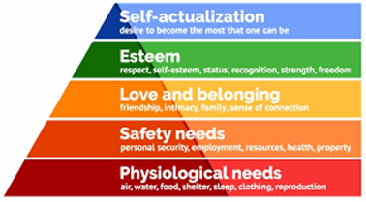 Central points in Maslow’s hierarchy of needs
- People tend to meet their needs systematically, starting with physiological needs then moving up the hierarchy.
- Until a particular group or needs is satisfied, a person’s behavior will be dominated by them
Herzberg’s Dual-Factor Theory
- Herzberg’s original study consisted of interviews with 203 accountants and engineers.
- The object of the research being to design jobs that provided job satisfaction, thereby encouraging higher levels of performance.
Job satisfaction=a feeling of fulfillment or enjoyment that a person derives from their job.

- This process developed into job enrichment.
Job enrichment=Fredrick Herzberg gave greater emphasis on job enrichment in his two factor theory. He assumed that in order to motivate personnel, the job must be designed to provide opportunities for achievement, recognition, responsibility, advancement and growth. This technique entails enriching the job so that these factors are included. It simply means, adding a few more motivators to a job to make it more rewarding. A job is enriched when the nature of the job is made more exciting, challenging and creative or gives the job holder more decision making, planning and controlling powers.
Job enrichment is a process that is characterized by adding dimensions to existing jobs to make them more motivating. Examples of job enrichment include adding extra tasks (also called job enlargement), increasing skill variety, adding meaning to jobs, creating autonomy, and giving feedback.

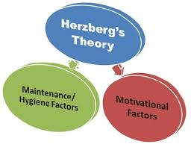
Motivating Factors | Hygiene Factors
Achievement | Company policy
Recognition | Supervision
Work itself | Working conditions
Responsibility | Interpersonal relationships at work
Advancement | Salary and benefits
Growth | Job security

Herzberg’s two factor theory:
He concentrated on satisfaction as work. From the study he came to conclude that certain factors tend to lead to job satisfaction while others frequently led to dissatisfaction. Factors giving rise to satisfaction were called motivators. Those leading to dissatisfaction were called hygiene factors.
According to Herzberg, motivating factors (also called job satisfiers) are primarily intrinsic job elements that lead to satisfaction. Hygiene factors (also called job dissatisfiers) are extrinsic elements of the work environment. A summary of motivating and hygiene factors appears in (Figure).
One of the most interesting results of Herzberg’s studies was the implication that the opposite of satisfaction is not dissatisfaction. Herzberg believed that proper management of hygiene factors could prevent employee dissatisfaction, but that these factors could not serve as a source of satisfaction or motivation. Good working conditions, for instance, will keep employees at a job but won’t make them work harder. But poor working conditions, which are job dissatisfiers, may make employees quit. According to Herzberg, a manager who wants to increase employee satisfaction needs to focus on the motivating factors, or satisfiers. A job with many satisfiers will usually motivate workers, provide job satisfaction, and prompt effective performance. But a lack of job satisfiers doesn’t always lead to dissatisfaction and poor performance; instead, a lack of job satisfiers may merely lead to workers doing an adequate job, rather than their best.
Important motivators/Growth Factors (satisfiers)
1. These factors, if present, serve to motivate the individual to superior effort and performance. 2. These factors are related to the job content of the work itself. 3. The strength of these factors will affect feelings of satisfaction or no satisfaction, but not dissatisfaction.
They include;
- Achievement for performing a task
- Recognition and praise
- Work itself
- Responsibility for one’s work
- Advancement: through promotion
Hygiene factors/Maintenance Factors (disatisfiers)
- These are the factors, which if absent, cause dissatisfaction.
- They are related to the job context and concerned with the job environment.
- They serve to prevent dissatisfaction.
- They act as a ‘platform’ upon which the satisfaction factors can be built.
- Unsatisfactory hygiene factors lead to dissatisfaction which lead to increased absences, grievances or resignations. He likens hygiene factors to water filtration pump. Not having one will likely result to illness, but drinking purified water will not necessarily keep one from becoming sick.
They include;
- Company policy and administration
- Supervision – the technical aspects
- Salary
- Interpersonal relationships – supervision
- Working conditions
McGregor’s Theory X, Theory Y
- McGregor put forward two suppositions (the fact of believing something is true without any proof or something that you believe to be true without any proof; something that is supposed; assumption; hypothesis) about human nature and behaviour at work.
- He argues that the style of management adopted is a function of the managers attitudes towards people and assumptions about human nature and behaviour.
- McGregor –theory X and theory Y are essentially sets of assumptions about behavior. He saw two different sets of assumptions made by managers about their employees, one which is negative ,theory X and the other positive, theory Y
- Theory X and Theory Y refer to two styles of management – authoritarian (Theory X) and participative (Theory Y). If you believe that your team members dislike their work and have little motivation, then, according to McGregor, you'll likely use an authoritarian style of management. This approach is very "hands-on" and usually involves micromanaging people's work to ensure that it gets done properly. McGregor called this Theory X.
- On the other hand, if you believe that your people take pride in their work and see it as a challenge , then you'll more likely adopt a participative management style. Managers who use this approach trust their people to take ownership of their work and do it effectively by themselves. McGregor called this Theory Y.
- The approach that you take will have a significant impact on your ability to motivate your team members. So, it's important to understand how your perceptions of what motivates them can shape your management style.

Theory X

Theory X managers tend to take a pessimistic view of their people, and assume that they are naturally unmotivated and dislike work. As a result, they think that team members need to be prompted, rewarded or punished constantly to make sure that they complete their tasks.
Work in organizations that are managed like this can be repetitive, and people are often motivated with a "carrot and stick" approach. Performance appraisals and remuneration are usually based on tangible results, such as sales figures or product output, and are used to control staff and "keep tabs" on them.

This style of management assumes that workers:
- Dislike their work.
- Avoid responsibility and need constant direction.
- Have to be controlled, forced and threatened to deliver work.
- Need to be supervised at every step.
- Have no incentive to work or ambition, and therefore need to be enticed by rewards to achieve goals.
According to McGregor, organizations with a Theory X approach tend to have several tiers of managers and supervisors to oversee and direct workers. Authority is rarely delegated, and control remains firmly centralized. Managers are more authoritarian and actively intervene to get things done.
Although Theory X management has largely fallen out of fashion in recent times, big organizations may find that adopting it is unavoidable due to the sheer number of people that they employ and the tight deadlines that they have to meet.

Theory Y

Theory Y managers have an optimistic, positive opinion of their people, and they use a decentralized, participative management style. This encourages a more collaborative , trust-based relationship between managers and their team members.
People have greater responsibility, and managers encourage them to develop their skills and suggest improvements. Appraisals (an act of assessing something or someone; assessment, evaluation) are regular but, unlike in Theory X organizations, they are used to encourage open communication rather than control staff.
Theory Y organizations also give employees frequent opportunities for promotion.

This style of management assumes that workers are:
- Happy to work on their own initiative.
- More involved in decision making.
- Self-motivated to complete their tasks.
- Enjoy taking ownership of their work.
- Seek and accept responsibility, and need little direction.
- View work as fulfilling and challenging.
- Solve problems creatively and imaginatively.
Theory Y has become more popular among organizations. This reflects workers' increasing desire for more meaningful careers that provide them with more than just money.
It's also viewed by McGregor as superior to Theory X, which, he says, reduces workers to "cogs in a machine," and likely demotivates people in the long term.
THEORY X (McGregor)
- Theory X represents the assumptions on which traditional organisations are based, and was widely accepted and practised before the development of the human relations approach.
- The central principle is direction and control through a centralised system of organisation and the exercise of authority
Theory X assumptions
Coerce= pressurize (an unwilling person) to do something by using force or threats.
Consistent= in agreement or harmony; in accord; compatible.

- Human beings are lazy, dislike work and avoid it as far as possible
- Since human beings dislike work they must be coerced, controlled or threatened with punishment to achieve goals
- Human beings will avoid responsibility, and want to be directed whenever possible
- Human beings place security above all other factors associated with work and will display little ambition
THEORY Y (McGregor)
- Theory Y represents the assumptions consistent with current research knowledge.
- The central principle is the integration of the individual and organisation goals.
- It is recognised as the best way to elicit co-operation from workers
Theory Y assumptions
- For most people work is as natural as play or rest.
- People will exercise self-direction and self-control in the service of objectives to which they are committed.
- Commitment to objectives is a function of rewards associated with their achievement.
- Given the right conditions the average worker can learn to accept and to seek responsibility.
- The capacity for creativity in solving organisational problems is distributed.
- The intellectual potential of the average person is only partially utilised.
- Motivation occurs at all of Maslow’s levels
Expectancy Theory
- Vroom’s expectancy theory(1964) maintains that employees behave in ways they expect will produce positive outcomes.
- The model suggest that the persons level of effort or force (motivation) is not simply a function of rewards.
- It is a measure of the strength of a particular outcome has for the individual
Vrooms expectancy theory is:
F = Sum (E * V) where,
F = Force - the motivation or the force used to achieve it.
E = Expectancy - the possibility of achieving a certain outcome through certain actions.
V = Valency - the preference an individual has for a particular outcome, the worth placed on a particular result.
- Porter and Lawler (1968) develop Vroom’s expectancy theory by suggesting that there are two factors determining the effort people put into their jobs.
- The value of the reward to individuals in so far as they satisfy their need for security, social esteem, autonomy and self-actualisation.
- The probability that reward depends on effort, as perceived by individuals - in other words their expectations of the relationship between effort and reward.
- Thus the greater the value of a set of rewards and the higher the probability that receiving each of these rewards depends upon effort, the greater the effort that will be made in a given situation.
Expectancy theory, initially put forward by Victor Vroom at the Yale School of Management, suggests that behavior is motivated by anticipated results or consequences. Vroom proposed that a person decides to behave in a certain way based on the expected result of the chosen behavior. For example, people will be willing to work harder if they think the extra effort will be rewarded.
Vroom stresses and focuses on outcomes, and not on needs unlike Maslow and Herzberg. The theory states that the intensity of a tendency to perform in a particular manner is dependent on the intensity of an expectation that the performance will be followed by a definite outcome and on the appeal of the outcome to the individual.
In essence, individuals make choices based on estimates of how well the expected results of a given behavior are going to match up with or eventually lead to the desired results. This process begins in childhood and continues throughout a person’s life. Expectancy theory has three components: expectancy, instrumentality, and valence.
- Expectancy is the individual’s belief that effort will lead to the intended performance goals. Expectancy describes the person’s belief that “I can do this.” Usually, this belief is based on an individual’s past experience, self-confidence, and the perceived difficulty of the performance standard or goal. Factors associated with the individual’s expectancy perception are competence, goal difficulty, and control.
- Instrumentality (reward) is the belief that a person will receive a desired outcome if the performance expectation is met. Instrumentality reflects the person’s belief that, “If I accomplish this, I will get that.” The desired outcome may come in the form of a pay increase, promotion, recognition, or sense of accomplishment. Having clear policies in place—preferably spelled out in a contract—guarantees that the reward will be delivered if the agreed-upon performance is met. Instrumentality is low when the outcome is vague or uncertain, or if the outcome is the same for all possible levels of performance.
- Valence is the unique value an individual places on a particular outcome. Valence captures the fact that “I find this particular outcome desirable because I’m me.” Factors associated with the individual’s valence are needs, goals, preferences, values, sources of motivation, and the strength of an individual’s preference for a particular outcome. An outcome that one employee finds motivating and desirable—such as a bonus or pay raise—may not be motivating and desirable to another (who may, for example, prefer greater recognition or more flexible working hours).
Expectancy theory, when properly followed, can help managers understand how individuals are motivated to choose among various behavioral alternatives. To enhance the connection between performance and outcomes, managers should use systems that tie rewards very closely to performance. They can also use training to help employees improve their abilities and believe that added effort will, in fact, lead to better performance.
Vroom was of view that employees consciously decide whether to perform or not at the job. This decision solely depended on the employee’s motivation level which in turn depends on three factors of expectancy, valence and instrumentality.
Advantages of the Expectancy Theory
- It is based on self-interest individual who want to achieve maximum satisfaction and who wants to minimize dissatisfaction.
- This theory stresses upon the expectations and perception; what is real and actual is immaterial.
- It emphasizes on rewards or pay-offs.
- It focuses on psychological extravagance where final objective of individual is to attain maximum pleasure and least pain.
Limitations of the Expectancy Theory
- The expectancy theory seems to be idealistic because quite a few individuals perceive high degree correlation between performance and rewards.
- The application of this theory is limited as reward is not directly correlated with performance in many organizations. It is related to other parameters also such as position, effort, responsibility, education, etc.
Implications of the Expectancy Theory
The managers can correlate the preferred outcomes to the aimed performance levels.
The managers must ensure that the employees can achieve the aimed performance levels.
The deserving employees must be rewarded for their exceptional performance.
The reward system must be fair and just in an organization.
Organizations must design interesting, dynamic and challenging jobs.
The employee’s motivation level should be continually assessed through various techniques such as questionnaire, personal interviews

Adams Equity Theory
- Equity theory focuses on peoples feelings of how fairly they feel they have been treated in comparison with the treatment received by others.
- It is based on exchange theory.
- People expect certain outcomes in exchange for certain inputs or contributions.
- Adams states that people will be better motivated if they are treated equitably.
The exchange variables are:
• Inputs - what the individual brings to their employment in terms of effort, experience and skills.
• Outcomes - the range of factors the employee receives in return for their inputs i.e. all the financial and non-financial rewards.
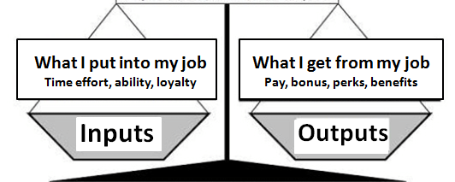

Alderfer’s ERG Theory
- This is a modified need hierarchy model and it condenses Maslow's five levels of need into only three levels based on the core needs of:
• Existence
• Relatedness
• Growth
- Existence needs are concerned with sustaining human existence and survival and cover physiological and safety needs of a material nature.
- Relatedness needs are concerned with relationships to the social environment and cover love or belonging, affiliation and meaningful interpersonal relations of a safety or esteem nature.
- Growth needs are concerned with the development of potential and cover self-esteem and self-actualisation.
- More than one need can be activated at the same time - a frustration-regression process e.g. if an individual is continually frustrated in an attempt to satisfy growth needs, relatedness needs may reassume most importance.
- ERG theory states that an individual is motivated to satisfy one or more basic sets of needs.
- If a persons needs at a particular level are blocked then attention should be focused on the satisfaction of needs at the other levels.
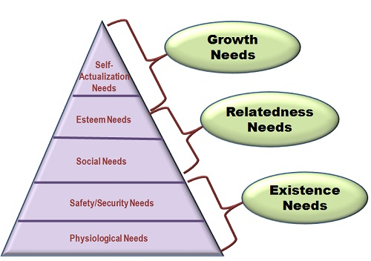
LYNDALL URWICK’S 10 PRINCIPLES OF ORGANISATION
- Objective- every org or part must have an expression of purpose, otherwise it is meaningless and therefore redundant.
- Specialization-activities confined to a single function.
- Co-ordination- facilitate co-ordination: unity of effort
- Authority-a supreme authority must rest somewhere, a clear line of authority to every individual in a group.
- Responsibility-of superior for acts of subordinates is absolute
- Definition-content of @position, duties involved, authority, responsibilities and relationship with others must be clearly defined in writing and published to all concerned!!
- Correspondence- in every position, responsibility and authority should correspond.
- Span of control-no persons should supervise more than 5 or at most 6 direct subordinates whose work interlocks!!
- Balance- various units of org’n must be kept in balance.
- Continuity-reorganization is a continuous process, in every undertaking specific provision should be made.

Topic 4: Leadership
Definition of Leadership
Leadership as the art of motivating a group of people to act towards achieving a common goal, It is also the process of persuading and influencing others towards a goal.

Definition of a leader
A leader is the person who influences and guides direction, opinion, and course of action. Also a leader is anyone who uses interpersonal skills to influence others to accomplish a specific goal (good or bad)

Characteristics of a leader
Leaders often do not have delegated authority but obtain their power through other means, such as influence.
I. Leaders may or may not be part of the formal organization.
II. Leaders focus on group process, information gathering, feedback, and empowering others.
III. Leaders emphasize interpersonal relationships.
IV. Leaders direct willing followers.
V. Leaders have goals that may or may not reflect those of the organization.
VI. Often do not have delegated authority

There are two types of leadership
- Formal leadership – Is practiced by a person with legitimate authority conferred by the organization and described in a job description who is a manager.

- Informal leadership – Is exercised by a staff member who does not have a specified management role. Informal leadership depends on one’s knowledge, status and personal skills in persuading and guiding others
- This implies that, all managers are formal leaders while not all leaders are manager because we have seen that there is informal type of leadership and managers work in a formal organization
Evolution of leadership theories
Leadership has evolved over period of time as you are going to learn in the following discussion
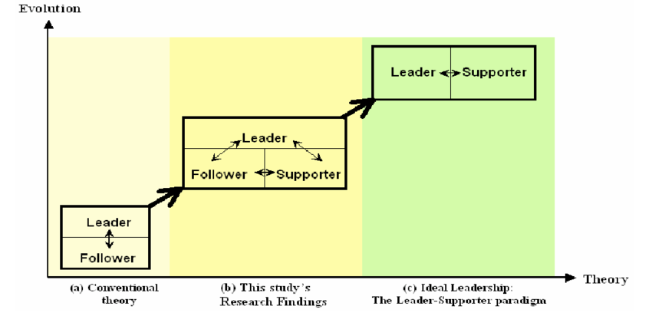
a. The Great man Theory (Trait Theories):
These were basis of leadership research until 1940’s. The great man theory asserts that some people are born to lead whereas others are born to be led. Trait theory assumes that some people have certain characteristics or personality traits that make them better leaders than others.
b. Behavioral Theories and leadership styles:
- During human relations era, many behavioral and social scientists studying management also studied leadership. Emphasis was on what the leader did or the behaviors of leaders. The behavioral view of leadership, personal traits only provide a foundation for leadership; effective leaders acquire a pattern of learned behaviors.
- The behavioral theories includes the leadership styles, system 4 management, the managerial grid and the continuum of leadership behavior
- Leadership styles: Lewin, Lippitt and White studied leadership styles. They identified three leadership styles which are authoritarian, democratic and Leissez-faire
• Authoritarian leader exhibits the following behaviors
- i) Strong control is maintained over the work group.
- ii) Others are motivated by coercion.
- iii) Others are directed with commands
- Iv)Communication flows downwards.
- v) Decision making does not involve others.
- vi) Emphasis is on difference in status (“I” and “you”).
- vii) Criticism is punitive (should be constructive)
- Democratic leader exhibits the following behaviors
- I. Less control is maintained.
- II. Economic and ego awards are used to motivate
- III. Others are directed thorough suggestions and guidance.
- IV. Communication flows up and down.
- V. Decision making involves others.
- VI. Emphasis is on “we” rather than “I” and “you”.
- VII. Criticism is constructive.
• A Leissez-faire leader is characterized by the following behaviors
- I. Is permissive with little or no control
- II. Motivate by support when requested by the group or individual
- III. Provides little or no direction.
- IV. Uses upward and downward communication
- V. Places emphasis on the group and does not criticize.
- VI. Laissez-faire leadership is appropriate when problems are poorly defined and brainstorming is needed to generate alternative solutions.
- System 4 management: This theory was developed by Likert. It is based on the premise that involving employees in decisions about work is central to effective leadership. It has four dimensions based on increasing levels of employee’s involvement in decision making
- Autocratic leaders – have little trust in employees and exclude them in decision making.
- Benevolent leaders – Are kind to employees but still do not involve them in decision making.
- Consultative leaders – Seek employee’s advice about decisions.
- Participative or democratic leaders – they value employees involvement, team work and team building. They also have high levels of confidence in employees and seek consensus in decision making
- The managerial grid: Another model of depicting leadership along a continuum is the managerial grid. Five leadership styles are plotted in four quadrants of a two dimensional grid. The grid depicts various degrees of leader concern for production (structure) and concern for people. These are
- Impoverished – Low concern for both production and people.
- Authority compliance – high concern for production and low concern for people.
- Middle of the road – moderate concern for production and people.
- Country club – High concern for people and low concern for production.
- Team – High concern for both production and people.
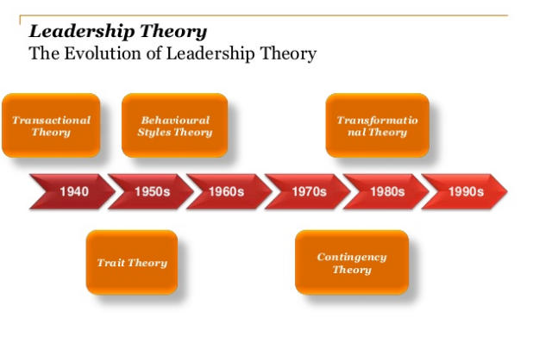

c. Situational and contingency theory:
- This combines traits and situation. The contingency theories suggest that the most effective leadership style is the one
- that best compliments the organizational environment, the task to be accomplished and the personal characteristic of
- the people involved in each situation. People become leaders because of their responsibility and situational
- factors.
d. Contemporary Theories of Leadership
- Leadership theory has continued to evolve. Contemporary approaches to leadership are underpinned by the belief that
- information power that was previously restricted to the professionals or managers is now available to all.
- The contemporary leadership theories includes
- The quantum leadership: A leadership style based on the concept of chaos theory
- Shared leadership, an organizational structure in which several individuals share the responsibility for achieving the organization’s goals.
- Servant leadership; the premise that leadership originates from a desire to serve; a leader emerges when others’ needs take priority.
- Transformational leadership; A leadership style focused on effecting revolutionary change in organizations through a commitment the organizations vision
- Burns (1978) suggested that both leaders and followers have the ability to raise each other to higher levels of motivation and morality. He identified this concept as transformational leadership. He maintained that there are two types of leaders in management.
- The traditional manager, concerned with the day to day operations was termed as Transactional Leader.
- The manager who is committed, has a vision and is able to empower others with this vision was termed as transformational leader .

Transactional Leader | Transformational Leader
Focuses on management tasks. | Identifies common values.
Is caretaker (takes care of tasks | Is committed (extramile)
Uses tradeoffs to meet goals | Inspires others with
Shared values not identified. | Has long term vision
Examiner causes. | Looks at effects.
Uses contingency rewards | Empowers others
Leadership Functions
Supervision (overseeing)
- Supervision is another leadership behavior.
- It includes inspecting another’s work, evaluating his/her performance and approving or correcting performance.
- Good supervision is facilitative because a good supervisor inspects work in progress and can remedy inadequate performance before serious consequences develop.
- The intensity of supervision should match situational requirements, employees needs and managers leadership skills
- Supervision must be appropriate in type and intensity for work groups members to interact effectively e.g. technical workers need closer supervision than professional workers
- A manager can effectively supervise a large number of subordinates when they are confined in a small area, perform similar jobs and are fairly educated.
- Intensity of supervision should also depend on manger-caregiver ration.
- The purpose of supervision is to inspect, evaluate and improve worker performance. Therefore a criteria is needed for judging the quality of work processes and outcomes.
- Job description and associated performance standards provide such evaluation criteria.
- The following performance elements should be appraised during supervision
- Quantity of work output
- Quality of output
- Time use
- Conservation of resources
- Assistance to co-workers
- Support of administrator
Co-ordination
- This is another leadership activity. It includes all activities that enable work group members to work together harmoniously.
- Co-ordination ensures that everything that needs to be done is done and that no two people are doing the same thing (or duplication of activity).
- Coordinating means distributing authority, providing channels of communication and arranging work so that the right things are done, at the right time, in the right place, in the right way and by the right people
- The overall results of coordination should be orderly work, harmonious, efficient and successful activities
Motivation
- Motivation describes the factors that initiate and direct behavior.
- Therefore a manager’s most important leadership task is to maximize subordinates work motivation because employees bring to the organization different needs and goals, the type and intensity of motivators vary among employees
- Therefore the manager must know which needs the employee expects to satisfy through employment and should be able to predict, which needs will be satisfied through the job duties and positions
- Motivated employees are more likely to be productive than non-motivated employees and hence motivation is an important aspect of enhancing employee performance.
How Leaders Influence Others
- Leadership, the foundation of the management function of leading, and a critical element of the health systems management building blocks is the process of influencing others toward the achievement of health care organizational goals (better health outcomes).
- Power is the capacity to affect the behavior of others.
- Effective leaders develop and use power, or the ability to influence others.
- Legitimate, reward, and coercive are all forms of power used by managers to change employee behavior.
Legitimate power
- Legitimate power stems from a formal management position in an organization and the authority granted to it. Subordinates accept this as a legitimate source of power and comply with it.
Reward power
- Reward power stems from the authority to reward others. Managers can give formal rewards, such as pay increases or promotions, and may also use praise, attention, and recognition to influence behavior.
Coercive power
- Coercive power is the opposite of reward power and stems from the authority to punish or to recommend punishment. Managers have coercive power when they have the right to fire or demote employees, criticize them, withhold pay increases, give reprimands, make negative entries in employee files, and so on.
Expert power
- Expert power results from a leader's special knowledge or skills regarding the tasks performed by followers. When a leader is a true expert, subordinates tend to go along quickly with his or her recommendations.
Referent power
Referent power results from leadership characteristics that command identification, respect, and admiration from subordinates who then desire to emulate the leader. When workers admire a supervisor because of the way he or she deals with them, the influence is based on referent power. Referent power depends on a leader's personal characteristics rather than on his or her formal title or position, and is most visible in the area of charismatic leadership.
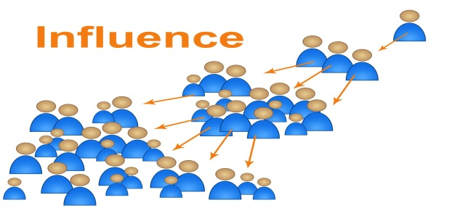

Functions of Management
- Management has been described as a social process involving responsibility for economical and effective planning and regulation of operation of an enterprise in the fulfilment of given purposes
- Remember in the definition of management we stated that it is a process. The core functions of management were identified by Henry Fayol as we have already seen in the management theories. The functions are planning, organizing, staffing, directing, coordinating and budgeting—as denoted by the mnemonic POSDCORB Where
- ✔ P – planning
- ✔O – organizing
- ✔S – staffing
- ✔D – directing
- ✔Co – coordinating
- ✔R – reporting
- ✔B – budgeting
Planning - best management function . planning is deciding in advance what to do ,when to do and how to do.
- It bridges the gap from where we are and we want to be. A plan is future course of action.
- It is an exercise in problem solving and decision making .planning is determination of course of action to achieve desired goals .
- Planning is important to ensure proper utilization of human and non human resources
Organizing – it is the process of bringing together physical ,financial and human resources and developing productive relationship amongst them for achievement of organizational goals.
- According to Henry Fayol to organize a business is to provide it with everything useful or its functioning i.e. raw materials tools capital and personnel
- Organization involves
- identification of activities
- Classification of grouping of activities
- Assignment of duties
- Delegation of duties and creation of responsibilities
- Coordinating authority and responsibility relationship
Staffing – it’s the function of maintaining the organization structure and keeping it manned .staffing has assumed greater importance in the recent years due to advancement of technology and increase in business. The main purpose of staffing is to put the right person on the right job. Management is manning of the organizational structure through proper and effective selection appraisal and development of personnel to fill the roles. Staffing involves
- Manpower planning
- Recruitment ,selection and placement
- Training and development
- Performance appraisal
- Promotion and transfer
Directing
Is the part of managerial function which directs the organizational to work efficiently for achievement of organizational purposes. It sets in the motion of action. Direction is the interpersonal aspect of management which deals directly with influencing ,guiding ,supervising ,motivating subordinates for the achievement of organizational goals
Directing has the following elements
- Supervision - implies overseeing the work of subordinates by their superiors .it is the act of watching and directing work and workers
- Motivating- means inspiring ,stimulating or encouraging the subordinates with zeal to work .positive ,negative ,monetary ,non monetary incentives may be used
Leadership -is a process by which manager guides and influences the work of the subordinates in desired direction
Communication - is the process of passing information ,experience opinion from one person to another .it is a bridge of understanding
Controlling
It implies measurement of accomplishment against the standards and correction of deviation if any to ensure achievement of organizational goal. The purpose is to ensure that everything occurs in conformity with the standards. Controlling is the measurement and correction of performance activities of subordinates in order to make sure that the goals and objectives are achieved. Controlling has the following steps
Establishment of standard performance
- Measurement of actual performance
- Comparison of actual performance with standards
- Corrective action
Coordination
This is the unification integration synchronization of the efforts of the group of members so as to provide unity of action in pursuit of common goals. It is the hidden force which binds all the other functions of management. Is the integration of several parts in to orderly hole to achieve the purpose of understanding. Management achieves coordination through basic functions of management like planning ,organizing, staffing directing and controlling. Controlling is integral element through:
- Coordinating through planning
- Coordinating through organizing
- Coordinating through staffing
- Coordinating through directing
- Coordinating through controlling

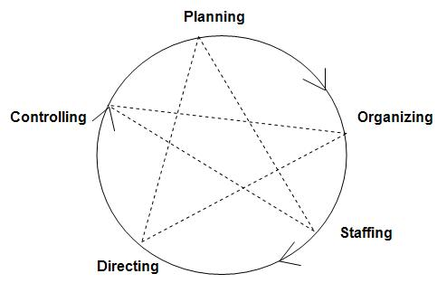

Topic 5: Planning
1. PLANNING
• OBJECTIVES
By the end of this lecture, you should be able to
- Explain planning and planning process.
- Describe the purposes of planning.
- Describe strategic planning and its importance in organizations
In our day to day living, we are involved in planning activities and programs. What plans did you make today before commencing work?
Planning is a management decision making process by which an organization decides what it wants to achieve, how it intends to achieve, in what manner
- It is the process of deciding in advance what to do, who is to do it and where it is to be done. Therefore all planning involves choice; a necessity to choose from among alternatives. Planning is a proactive and deliberate process.
- It is a function required of all managers so that personal as well as organizational needs and objectives can be met. This cyclic process allows for unity of goals, continuity of energy expenditure (human and fiscal resources) and an opportunity to minimize uncertainty and chance. The process also directs attention to the objectives of the organization and provides the manager with a means of control. Planning precedes all other management functions and without adequate planning the management process will fail.
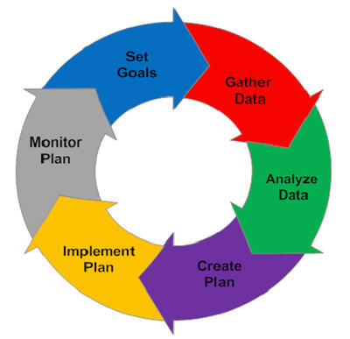

TERMINOLOGIES USED IN PLANNING
Philosophy
It is a statement of beliefs based on core values – inner forces that give us purpose. Philosophy states the values and beliefs held about the nature of work required to accomplish the mission and the nature and rights of both the people being served and those providing the service.
Mission
It is a broad general statement of the organization reason for existence. It states where the organization is now, where it wants to go and how it intends to get there. The mission identifies the organization customers and the type of services offered
Vision
A vision statement describes the goal to which the organization aspires. It delineates the set of values and beliefs that guide all actions of the organization. Vision statements are future oriented purposeful statements designed to identify the desired future of an organization.Within this context, mission and philosophy statements are crafted.
The goal
May be defined as the desired result towards which effort are directed. This is a specific aim or target that the unit wishes to attain within a time span e.g. of 1 year. They are measurable and precise. Goals like values and philosophies change with time and require periodic re-evaluation
Objectives
An objective is the desired end results of any activity. They specify what an organization is meant to accomplish
Policy
Statements of conduct, principles designed to influence decisions and actions). They make managers take action in a certain way. These are plans reduced to statements or instructions that direct organization in decision making.
Procedure
A procedure is a series of steps for the accomplishment of some specific project or endeavor. It is a chronological sequence of steps to be undertaken to attain an objective.
Rules and Regulations
Are plans that define specific action or non-action. Rules describe situations that allow only one choice of action.
TYPES OF PLANNING
Planning can be classified on the basis of time, nature and use of plans.
Based on time, we have the following types based on time
- Long period planning - This normally covers a period of more than five years though it can extend up to 20years or so. They are developed to guide the future efforts of an organization. Long term planning is mainly the responsibility of the top management
- Short period planning - This refers to determination of courses of action for the time period extending up to one to three years. In short term planning the structure is fixed and specific activities required to achieve goals are developed. Its formulated by lower level management
Based on nature, we have the following types based on nature
- Strategic planning - Strategic planning is a process that is designed to achieve goals in
- dynamic competitive environment through the allocation of resources. Drucker (1973 defines strategic planning as a continuous systematic process of making risk-taking decisions today with the greatest possible knowledge of their effects on the future

Planning Process
The process of planning is comprised of four stages. These are :
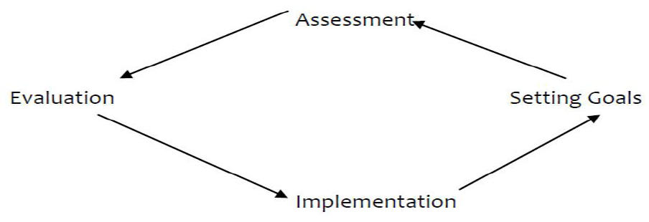
• - Assessment
• - Setting goals
• - Implementation
• - Evaluation

Steps in strategic planning process/planning cycle
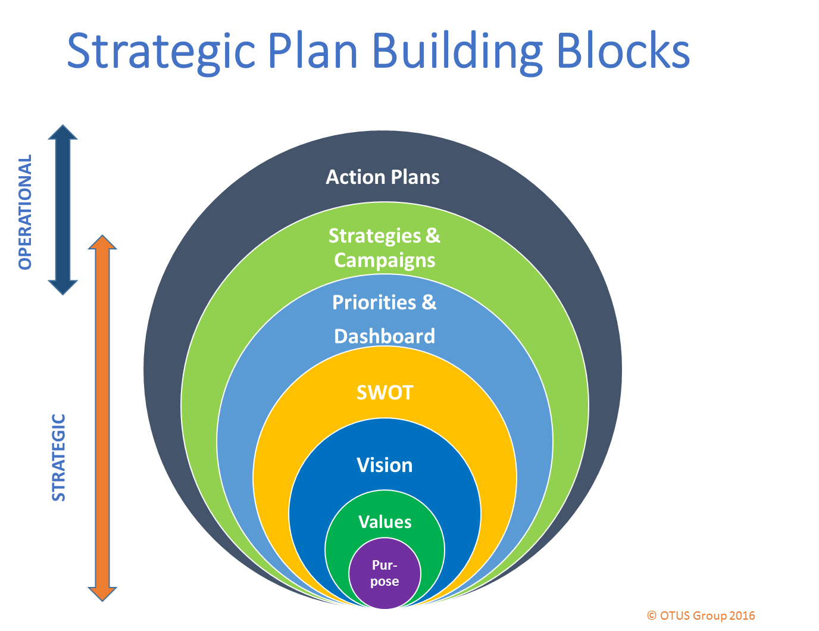
1. Environmental scanning
- This involves assessment of the External an Internal-environment
- The economic, demographic, technological, social, educational and political factors are assessed in terms of their impact on opportunities and threats within the environment Internal environment assessment (SW) includes review of the effectiveness of the structure size, programmes, financial resources, human resources, information system, research and development capabilities of the organization
2: Strategy formulation
- This includes the development of the mission, specifying objectives, developing strategies and setting policy guidelines.
- Mission: The development of the mission statement provides a sense of direction and focus and draws the organization together.
- The purpose of the mission statement is to communicate what the organization stands for and where it is heading. Mission statement answers the question, why do we exist. Everyone should participate in deciding of the mission statement.
- Goal Setting: This is the process of developing, negotiating and formalizing the targets or objectives that an employee s responsible for accomplishing (performance standards). Goals assist the managers to focus attention on what is relevant and to develop strategies and actions to achieve the goal.
- Objectives: Objectives should be challenging, measurable, consistent, achievable, reasonable and clear. Smart – outcome oriented
3: Identification of strategies:
Strategy determines how the organization will go about attaining their vision i.e. how it will exploit the external opportunities and internal strengths and counter external threats and internal weaknesses. This involves preparing a detailed plan of action, either short-term and long-term objectives. Formulation of annual departmental objectives, resource allocation and preparation of budgets is also done at this stage. Strategies may include; retrenchment, expansion, recruitment etc
4: Strategy Implementation
This is the action stage. The specific plans for action are implemented in order of priority. It entails open communication with staff in regard to priorities and formulation of area and individual objectives related to the plan. Resource allocation (human/non human allows for strategy execution. Resources are allocated in order of priority i.e. established by annual objectives.
5: Strategy Evaluation
- At set periods, the strategic plan is reviewed at all levels to determine if the goals, objectives and activities are on target. Monitors the results of formulation and implementation of activities and includes measuring individual and organizational performance and taking corrective actions when necessary
- Operational planning/tactical planning
- This is tactical planning and a short term exercise designed to implement the strategies formulated under strategic planning. It is based on strategic plans.

Purposes of Planning (Significance)
Planning has many important purposes which include some of the following:
- Contributes to a purposeful organization.
- Reduces costs. Efforts will be better directed toward desired results
- Provides for integration and coordination of activities.
- Haphazard approaches can be minimized and duplications avoided.
- Provides for consistency of action which is necessary so that both internal and external people can anticipate the organizations
Difficulties Encountered In Planning
- Plans tend to be slow when joint efforts of several individuals are needed.
- There is friction as people bring together their ideas to make a decision.
- Differences in perception of objectives.
- Communication problems.
- Persuasive ability of the impressive individual.

Review Questions/Unit Activity
Find out the vision, mission and philosophy of your institution. To what extent does the institution subscribe to them?
Assignment
List five differences between the characteristics of a leader and a manager (10 mar
GOOGLE
- Day 1 (October 1, 2012 => 10:00 a.m.-12:00 p.m. )1. Definitions of Management and Health Management2.Historical Development of Management3.Management and Administration4.Management Functions
- 8. 1. Definitions of Management and Health Management ⎫ Management may be defined as 1. Getting things done! 2. Process of reaching organizational goals by working with and through people and other resources 3. The process of directing, co-ordinating, and influencing the operations of an organization so as to obtain desired results and enhance total performance ⎫ Health Management, therefore, is ϖThe application of management principles for health care
- 9. 2. Historical Development of ManagementA. Development of Management Thought• The problem of organizing men to achieve the desired objective is not new. It is as old as civilization itself.• The Practice of Management has existed ever since man has been organized into communities.• The study of management as a separate and distinct subject with different theories and techniques is a product of 20th century• Most writers agree that the origin of this discipline was the work of Frederick Winslow Taylor during the scientific Management movement that developed around 1900
- 10. B. Pre-Scientific Management Era⎫ Thousands of years a go-The Chinese, The Babylonians, The Egyptians, The Greek, The Romans and the Hindus philosophers wrote extremely interesting books and propounded theories which are followed even today.⎫ Development of management as a science is of recent origin, even though its practice is as old as civilization⎫ With the advent of industrial revolution management of enterprises assumed an increasingly important role
- 11. C. Importance of Management⎫ Management is universal and necessary function⎫ It is essential for all kinds of organizations. This is because every organization requires:- ϖThe making of decisions ϖThe coordinating of activities ϖThe handling of people and ϖEvaluating the performance directed toward its objectives⎫ Management is a social science and deals with the behavior of people in the organization
- 12. 3. Management and Administration• The term “Management” and “Administration” are used interchangeably in government and business organizations.• However, they don’t mean the same.• Administration- is essentially overall determination of polices and major objectives• Management- is essentially an executive function, the active direction of human effort
- 13. • Administration • Management – Determinative – Executive ϖ Functionally involved in – Is a science, an art and a 1. The laying down of the profession general purpose of the ϖ Functionally involved in organization 1. Planning 2. The framing of its major 2. Organizing objectives 3. Staffing 3. The formulation of general 4. Directing plan of procedure 5. Controlling 4. The inauguration of broad program – Or broadly 5. Approval of specific major 1. Planning projects that fall within the 2. Implementing general program 3. Evaluation
- 14. • The same person may perform both administrative and managerial functions at the same time but to different extent• The Administrator would devote a greater part of his/her time to the broader administrative responsibilities, but will also participate (though limited extent) in executing those polices• Similarly, Manager determines policies in a limited sphere and so perform administrative function• As we go down the hierarchical ladder, the administrative function becomes less and less and the management function more and more
- 15. 4. Management FunctionsQ 1. What is Function?Ans. Broad area of responsibility composed of many activities aimed at achieving a predetermined objectiveQ 2. What are the functions of Management?Ans. Management has five functions. These are:-1. Planning (Chapter Two-6 hrs)2. Organizing (Chapter Three-4 hrs)3. Staffing (Chapter Four-4 hrs)4. Directing (Chapter Five-3 hrs)5. Controlling (Chapter Six-3 hrs)
- 16. A. Planning• A plan is a predetermined course of action which provides purpose and direction of an organization.• Planning is foreseeing future circumstances and requirements, then, setting objectives, making long and short term plans and determining the policies to be followed with standards to be set• In planning, managers receive and store information, monitor and disseminate the information. A manager makes decisions on strategy and allocation of resources and initiate planned changes
- 17. B. Organizing• This is the identification and classification of the required activities, the grouping of activities necessary to attain objectives, the assignment of each grouping to a manager with authority and the provision of coordination• In organizing, structures are created, relationships established and resources are allocated for the accomplishment of activities• In organizing, plans are reviewed, tasks to be performed are listed, tasks are grouped into jobs that can be done by an individual, departments are created, work is assigned to individuals and authority is delegated
- 18. C. Staffing• Staffing involves manning the organizational structure through proper and effective appraisal, selection and development of people to fill the roles designed into the structure.• Staffing is also known as Human Resource Management. In other words, it is the management function devoted to acquiring, training, appraising, and compensating employees.• Staffing process involves: 1. Development of organizational structure 2. Assessment of manpower required and available. 3. Assessment of their quality, qualification and skills for the job. 4. Appraisal –Strength and shortcomings 5. Conduct development programs
- 19. D. Directing/Leading• Leading is the process of influencing people so that they will contribute to organization and group goals• Directing involves the initiation of action and it entails three elements that are action oriented in nature.• These are – motivation, – communication and – leadership
- 20. E. Controlling• This is the measurement and correction of performance in order to ensure that enterprise objectives and plans devised to attain them are accomplished• Controlling is a function of every manager both at lower and upper level since all have responsibility for the execution of plans.• In controlling we must: – Establish standards – Measure performance – Correct deviations
- 21. • Management can also have three broad sequential functions – Planning – Implementation and – Evaluation• Two continuous functions of management are – Communication – Decision-Making
- 22. • Communication – During the process of planning, implementation and evaluation, it is necessary for sharing ideas/information between the ϖManager ϖStaff and the ϖCommunity• Decision making – Planning, implementation and evaluation require decision making as a task.
- 23. Day 2 (October 3, 2012 => 10:00 a.m.-12:00 p.m. )5. Management and Environment6. Role and Types of Managers7. Management Skills8. Concepts and Principles of Management
- 24. 5. Management and Environment• Health service organizations are affected by the external environment and vice versa• Management performs all the functions of management in interaction with its environment• Organizations are open systems!• Management while performing its various functions continually adopt itself to changes occurring in its environment• Organizations process inputs (human resource, materials, Finances, Information, Technology, and Time) into outputs in the form of goods (products), services and deliver them to the environment.
- 25. ⎫ Components of the external environment1. Political i. Policy ii. Political institution/organization iii. Government officials/institution2. Economic and Business Communities i. Suppliers ii. Clients iii. Farmers iv. Merchants v. Share-holders
- 26. 3. Social i. Community ii. Leaders4. Technological i. Medical equipment ii. Strategies, e.g. Community based distribution5. National and International Issues
- 27. 6. Role and Types of Health Managers• Defining managers by their managerial roles was presented and developed by Henry Mintzberg in 1970s• Managerial roles are categorized into three major areas with further classification A. Interpersonal role B. Information role C. Decision Making role
- 28. A. Interpersonal Role-shows the interpersonal contact that a manger does which is vital in his/her daily activities.• Interpersonal roles are designated by 1. Figurehead- this role symbolizes the legal authority of the manager such as: attending ceremonies, signing documents… 2. Leader- this role holds him accountable, responsible, and motivator of the staff he is working with 3. Liaison- this role enables the manager creates links in horizontal as well as vertical chain of communications that facilitate communication in and out side the organization
- 29. B. Information Role-this role is related to communication and information channeling 1. Monitor-Serving as a focal person for all types of communications 2. Disseminator-Communicating selected information to subordinates 3. Spokesperson-Communicating selected information to outsiders
- 30. C. Decision Making Role -A manager has a legal authority to decide on matters that are assigned to him based on his job description1. Entrepreneur -designing and initiating changes within the organization2. Disturbance handler -taking corrective action and handling conflicts3. Resource allocator -decides on resources and their distribution4. Negotiator –Negotiating with other parties representing organizational interests
- 31. 7. Types of Health Service Managers1. First Line (or first level) Manager – Managers who are responsible for the work of operating and do not supervise other managers – They are the first or lowest level of mangers in the organizational hierarchy2. Middle Managers – Managers in the mid range of the organizational hierarchy – They are responsible for other managers and sometimes for some operating employees – They report to more senior managers3. Top Managers – Managers responsible for the overall management of the organization – They establish, operating policies and guide the organization’s interaction with its environment
- 32. 8. Management Level and Skills1. Technical Skill◊ Low Level ◊ First Line – The understanding of technical element of activities in general and proficiency in specific kind of technical activity2. Human Skill ◊ Middle Level – This is the ability to work with others and win cooperation from the health team other sectors and the community3. Conceptual Skill◊ Top Level (senior) – The ability to visualize the organization as the whole and its relationship with the community and other sectors
- 33. 9. Concepts and principles in Management• In the process of fulfilling his/her managerial duties the manager would apply the following concepts and principlesA. Concepts 1. Effectiveness 2. Efficiency 3. Economy of Scarce Resources 4. Work Relations 5. Information
- 34. 1. Effectiveness – The degree to which stated objective is being achieved – It is something that management tries to improve2. Efficiency – It is concerned with the balanced use of resources (money, material, human resources, time, space, and information)3. Economy of Scarce Resources – Some and often many resources are scarce and costly thus we have to economize
- 35. 4. Work Relations – Work activities should be designed and structured so as to support each other towards the achievement of objectives5. Information – Management needs information if it is to make the right decision for action. – At the same time, information can easily handicap management, if it is not • The right kind • At the right time • In the right hands
- 36. B. Principles1. Management by Objectives2. Learn from Experience3. Division of Labour4. Substitution of Resources5. Convergence of Work6. Functions Determine Structure7. Delegation8. Management by exception9. Shortest decision path
- 37. 1. Management by objectives – Management sees that objectives are specified and then that they are achieved – The objectives should state 1. What is accomplished? 2. How much of it? 3. Where is it to be done? 4. When it is to be completed? – Therefore a clear statement of objectives makes it possible to evaluate how effective one is in approaching and reaching the objectives
- 38. 2. Learning from experience – Analysis of the results between the objectives and achievement made. For better performance there should be feedback to learn from the experience gained3. Division of Labor – Management attempts to bring about balance of work among tht different people concerned4. Substitution of Resources – Often when the resources that are normally used to provide service became scarce or too expensive, different resources may be used to provide the intended results
- 39. 5. Convergence of Work – Working relations should contribute to the success of each activity and so to general effectiveness. – Theses working relations of activities are • The logical relations with each other • Time relations or sequence • Spatial relations between activities • Functional and structural-working relations between people6. Functions Determine Structure – When the work is defined i.e. the function and duties of the individual members of the team are clearly defined and known to all, the working relations of the structure follow. – The exact nature of authority will be clearly delineated on the structure7. Delegation – Delegation takes place when some body’s authority is lent so as to enable that person to take responsibility when the occasion arises
- 40. 8. Management by exception• In effect this means two things1. Don’t be overloaded with routine, unnecessary information, be selective2. Make BIG decision firstIn short management by exception means1. selectivity in information2. priority in decision9. Shortest decision path• This principle deals with issue – Who should make which decision? – When and Where?• Decision must be made as closely as possible in time and place to the object of decision and to those affected by it
- 41. Questions For Review
- 42. Q. Why do you learn the course Health Service Management?Q. Do you think Learning Health Service Management is important to foster equitable health care and justice in health?
- 43. Q. Assume that you are working as a manager of certain health center in Tigray. A supervisor from Regional Health Bureau came to you. on behalf of your team, you explained to him every thing he claimed to know about your health center. Which one of your managerial role are you playing in this scenario? a) Disseminator b) Monitor c) Spokesperson d) Entrepreneur
- 44. Q. While working as head of certain health center Amina who is a newly hired nurse at your health center mistreats patients and she usually insults them. You spotted her while committing the same mistake and you called her to your office. You told her being in the most rewarding profession, she is one of the God’s army and God’s choice to save patients from suffering and her services are earthly divine. Besides patients are likely to accept her orders to take medication if she keeps humble and treats them respectfully. After she heard this she become motivated and told you that she will be happy to accept your comments and serve the patients in a nice way. You played which of your managerial roles in this case?A. FigureheadB. LeaderC. Disturbance handlerD. MonitorE. B and C
- 45. Q. Which one of the following is FALSE? a) Management branch of social science that deals with human behavior b) Management is indispensible part of every organization to enhance total performance c) Management and administration are words of the same meaning which can be used interchangeably d) Management is as old as human history
- 46. Q4. Broad area of responsibility composed of many activities aimed at achieving a predetermined objective is called__________ a) Management b) Administration c) Function
- 47. Q. What are functions of Management?Q. What are the 10 roles of Management?Q. Outline the difference in between Management and Administration?Q. What are the two indispensible components of every function of management?

